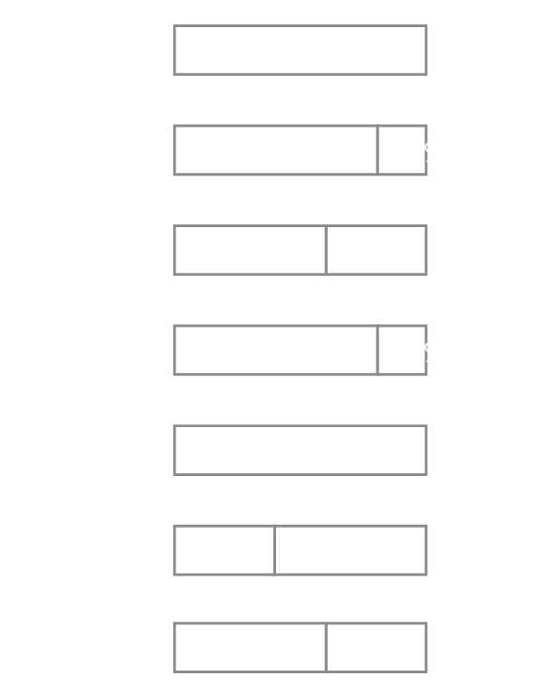

**SKILLS**

/Yourname

/Yourname

@Yourname

/Yourname

Penang, Malaysia

+01 234 5678

yourname@email.com

**CONTACT**

Financial Analyst

YOUR NAME HERE

**ABOUT**

**WORK EXPERIENCE**

**2012 - 2014**

**University of Waterloo (Waterloo, Canada)** Add date here

**BACHELORS IN BUSINESS ADMINISTRATION, ACCOUNTING**

**Rotman School of Business (Toronto, Canada)** Add date here

**MASTERS IN BUSINESS ADMINISTRATION**

**EDUCATION**

**Company name Inc. - Toronto, Canada**

**2009 - 2012**

**YET ANOTHER POSITION**

In short paragraphs or bullet points, describe your role, your main responsibilities and your achievements in this role. Be specific, data-driven and think of key phrases that are essential in a role you’re applying for

In short paragraphs or bullet points, describe your role, your main responsibilities and your achievements in this role. Be specific, data-driven and think of key phrases that are essential in a role you’re applying for

**Company name Inc. - Toronto, Canada**

**ANOTHER POSITION**

In short paragraphs or bullet points, describe your role, your main responsibilities and your achievements in this role. Be specific, data-driven and think of key phrases that are essential in a role you’re applying for

**Company name Inc. - Toronto, Canada**

**FINANCIAL ANALYST**

**2014 - 2018**

Use this paragraph to write sum up your work experience. Talk about the years of experience that you have in finance or a particular field, the specific expertise you bring to the table, sum up your education, any notable achievements, and also languages that you speak. This is your chance to shine!